ASSIGNMENT 4
Student Marks Management System
Unit – Arrays and Methods | Individual Coding Assignment
Student Name | Sasanka Sekhar Kundu
Assignment | Assignment 4 – Student Marks Management System
Programming Language | Java
IDE Used | Visual Studio Code

1. Objective
The objective of this assignment is to develop a menu-driven Java application for managing marks of five students in Java, Python, and DBMS. The program demonstrates 2-D and 1-D arrays, methods with parameter passing, Linear Search, Bubble Sort, loops, switch-case control flow, validation, and subject-wise analysis.

2. Problem Statement
The system stores marks for five students across three subjects and provides operations to display marks, calculate totals and averages, identify the highest scorer, search for a particular mark, sort student totals from highest to lowest, and display the highest mark in each subject.

3. Sample Marks Data
Student | Java | Python | DBMS
Student 1 | 78 | 82 | 75
Student 2 | 90 | 85 | 88
Student 3 | 65 | 72 | 70
Student 4 | 88 | 91 | 85
Student 5 | 55 | 60 | 58

4. Menu Operations
- 1. Display All Marks
- 2. Calculate Student Total
- 3. Calculate Student Average
- 4. Find Highest Scorer
- 5. Search Marks
- 6. Sort Student Totals
- 7. Display Subject-Wise Highest Marks
- 8. Exit

5. Concepts and Techniques Used
- 2-D array for student marks
- 1-D array for total marks
- Methods with arrays passed as parameters
- Loops for traversing students and subjects
- Switch statement for menu selection
- Linear Search for finding a mark
- Bubble Sort for descending student totals
- Scanner for user input
- Input validation using conditions, break, and continue

6. Method Summary
Method | Purpose
displayMarks(...) | Displays all students' marks in a formatted table.
calculateTotal(int[]) | Calculates one student's total.
calculateAllTotals(int[][]) | Builds the 1-D totals array.
calculateAverage(int[]) | Calculates one student's average.
findHighestScorer(int[]) | Finds the index of the highest scorer.
searchMarks(int[][], int) | Performs Linear Search.
searchAndDisplayMarks(...) | Reports every location where a mark occurs.
bubbleSort(int[], int[]) | Sorts totals high-to-low while preserving student indexes.
displaySortedTotals(...) | Displays the final ranking.

7. Complete Source Code
import java.util.Scanner;
public class StudentMarksManagementSystem {
public static void displayMarks(String[] students, String[] subjects, int[][] marks) {
System.out.println();
System.out.println("===== All Student Marks =====");
System.out.printf("%-12s %-10s %-10s %-10s%n",
"Student", "Java", "Python", "DBMS");
for (int i = 0; i < marks.length; i++) {
System.out.printf("%-12s %-10d %-10d %-10d%n",
students[i], marks[i][0], marks[i][1], marks[i][2]);
}
}
public static int calculateTotal(int[] studentMarks) {
int total = 0;
for (int mark : studentMarks) total += mark;
return total;
}
public static int[] calculateAllTotals(int[][] marks) {
int[] totals = new int[marks.length];
for (int i = 0; i < marks.length; i++)
totals[i] = calculateTotal(marks[i]);
return totals;
}
public static double calculateAverage(int[] studentMarks) {
return (double) calculateTotal(studentMarks) / studentMarks.length;
}
public static int findHighestScorer(int[] totals) {
int highestIndex = 0;
for (int i = 1; i < totals.length; i++)
if (totals[i] > totals[highestIndex]) highestIndex = i;
return highestIndex;
}
public static void searchAndDisplayMarks(String[] students, String[] subjects,
int[][] marks, int searchMark) {
boolean found = false;
System.out.println();
System.out.println("===== Linear Search =====");
System.out.println("Searching for mark : " + searchMark);
for (int i = 0; i < marks.length; i++) {
for (int j = 0; j < marks[i].length; j++) {
if (marks[i][j] == searchMark) {
System.out.println("Found " + searchMark + " marks in "
+ students[i] + " - " + subjects[j]);
found = true;
}
}
}
if (!found) System.out.println("Mark " + searchMark + " was not found.");
}
public static void bubbleSort(int[] totals, int[] studentIndexes) {
for (int i = 0; i < totals.length - 1; i++) {
for (int j = 0; j < totals.length - 1 - i; j++) {
if (totals[j] < totals[j + 1]) {
int tempTotal = totals[j];
totals[j] = totals[j + 1];
totals[j + 1] = tempTotal;
int tempIndex = studentIndexes[j];
studentIndexes[j] = studentIndexes[j + 1];
studentIndexes[j + 1] = tempIndex;
}
}
}
}
public static void displaySubjectHighestMarks(String[] subjects, int[][] marks) {
System.out.println();
System.out.println("===== Subject-Wise Highest Marks =====");
for (int j = 0; j < subjects.length; j++) {
int highest = marks[0][j];
for (int i = 1; i < marks.length; i++)
if (marks[i][j] > highest) highest = marks[i][j];
System.out.println("Highest " + subjects[j] + " Marks : " + highest);
}
}
public static void main(String[] args) {
Scanner scanner = new Scanner(System.in);
String[] students = {"Student 1","Student 2","Student 3","Student 4","Student 5"};
String[] subjects = {"Java","Python","DBMS"};
int[][] marks = {
{78, 82, 75},
{90, 85, 88},
{65, 72, 70},
{88, 91, 85},
{55, 60, 58}
};
int[] totals = calculateAllTotals(marks);
while (true) {
System.out.println();
System.out.println("===== Student Marks Management System =====");
System.out.println("1. Display All Marks");
System.out.println("2. Calculate Student Total");
System.out.println("3. Calculate Student Average");
System.out.println("4. Find Highest Scorer");
System.out.println("5. Search Marks");
System.out.println("6. Sort Student Totals");
System.out.println("7. Display Subject-Wise Highest Marks");
System.out.println("8. Exit");
System.out.println();
System.out.print("Enter your choice: ");
if (!scanner.hasNextInt()) {
System.out.println("Invalid input! Please enter a number from 1 to 8.");
scanner.next();
continue;
}
int choice = scanner.nextInt();
switch (choice) {
case 1:
displayMarks(students, subjects, marks);
break;
case 2:
System.out.print("Enter student number (1-5): ");
if (!scanner.hasNextInt()) {
System.out.println("Invalid input! Please enter a student number.");
scanner.next();
continue;
}
int totalStudent = scanner.nextInt();
if (totalStudent >= 1 && totalStudent <= 5)
System.out.println(students[totalStudent - 1] + " Total : "
+ calculateTotal(marks[totalStudent - 1]));
else System.out.println("Invalid student number!");
break;
case 3:
System.out.print("Enter student number (1-5): ");
if (!scanner.hasNextInt()) {
System.out.println("Invalid input! Please enter a student number.");
scanner.next();
continue;
}
int averageStudent = scanner.nextInt();
if (averageStudent >= 1 && averageStudent <= 5)
System.out.printf("%s Average : %.2f%n",
students[averageStudent - 1],
calculateAverage(marks[averageStudent - 1]));
else System.out.println("Invalid student number!");
break;
case 4:
int highestIndex = findHighestScorer(totals);
System.out.println("===== Highest Scorer =====");
System.out.println("Highest Scorer: " + students[highestIndex]);
System.out.println("Total Marks : " + totals[highestIndex]);
break;
case 5:
System.out.print("Enter mark to search: ");
if (!scanner.hasNextInt()) {
System.out.println("Invalid input! Please enter a mark.");
scanner.next();
continue;
}
int searchMark = scanner.nextInt();
if (searchMark < 0 || searchMark > 100) {
System.out.println("Invalid mark! Enter a value between 0 and 100.");
continue;
}
searchAndDisplayMarks(students, subjects, marks, searchMark);
break;
case 6:
int[] sortedTotals = totals.clone();
int[] studentIndexes = new int[students.length];
for (int i = 0; i < studentIndexes.length; i++) studentIndexes[i] = i;
bubbleSort(sortedTotals, studentIndexes);
System.out.println("===== Student Totals Ranking =====");
for (int i = 0; i < sortedTotals.length; i++)
System.out.println((i + 1) + ". "
+ students[studentIndexes[i]] + " : " + sortedTotals[i]);
break;
case 7:
displaySubjectHighestMarks(subjects, marks);
break;
case 8:
System.out.println("Thank you for using the Student Marks Management System.");
System.out.println("Program exited successfully.");
scanner.close();
break;
default:
System.out.println("Invalid menu choice! Please select 1 to 8.");
continue;
}
if (choice == 8) break;
}
}
}

8. Calculations and Results
Student 1 Total = 78 + 82 + 75 = 235; Average = 78.33
Student 2 Total = 90 + 85 + 88 = 263; Average = 87.67
Student 3 Total = 65 + 72 + 70 = 207; Average = 69.00
Student 4 Total = 88 + 91 + 85 = 264; Average = 88.00
Student 5 Total = 55 + 60 + 58 = 173; Average = 57.67
Highest Java Marks = 90
Highest Python Marks = 91
Highest DBMS Marks = 88
Highest Scorer = Student 4, with 264 total marks

9. Linear Search
The demonstrated test searched for mark 66. The program checked every element of the 2-D array and correctly reported that 66 was not found in the supplied data.

10. Bubble Sort Ranking
1. Student 4 : 264
2. Student 2 : 263
3. Student 1 : 235
4. Student 3 : 207
5. Student 5 : 173

11. Compilation and Execution
The program was successfully compiled and executed in the Visual Studio Code terminal using:
javac StudentMarksManagementSystem.java
java StudentMarksManagementSystem

12. Execution Screenshots
The following screenshots provide execution evidence from Visual Studio Code, covering the menu, marks display, student total and average, highest scorer, search, sorting, subject-wise highest marks, and successful exit.
Execution Screenshot 1
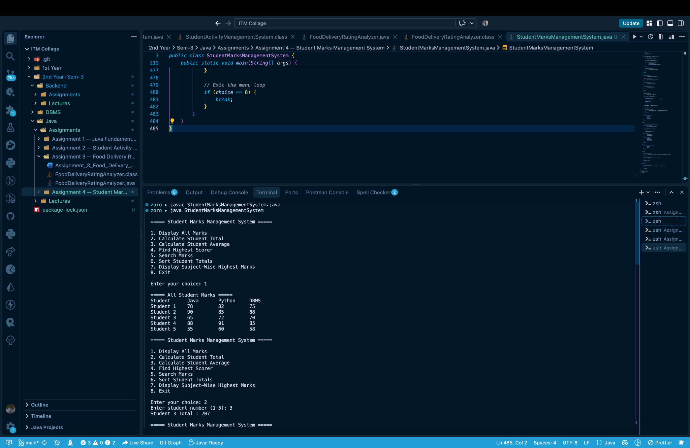
Execution Screenshot 2
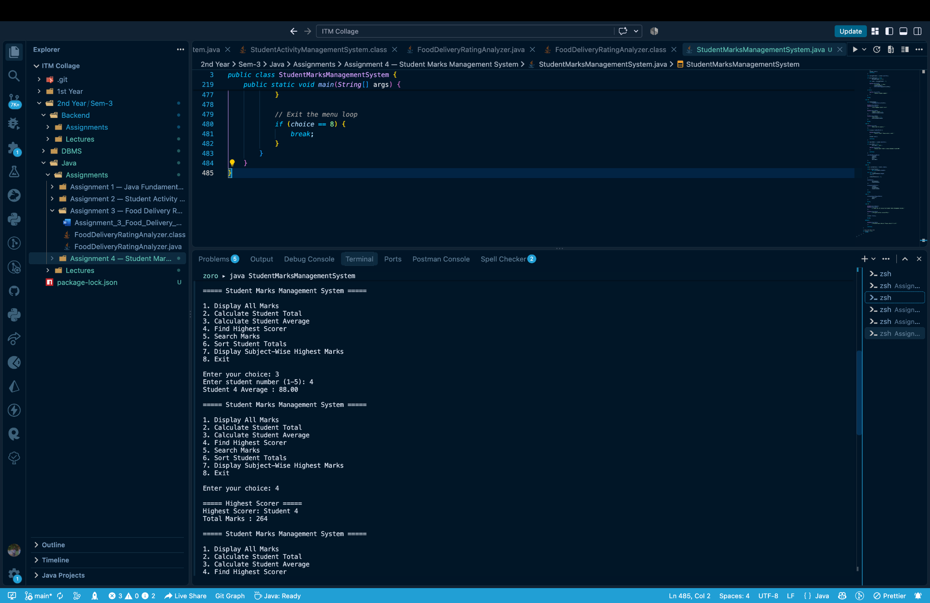
Execution Screenshot 3
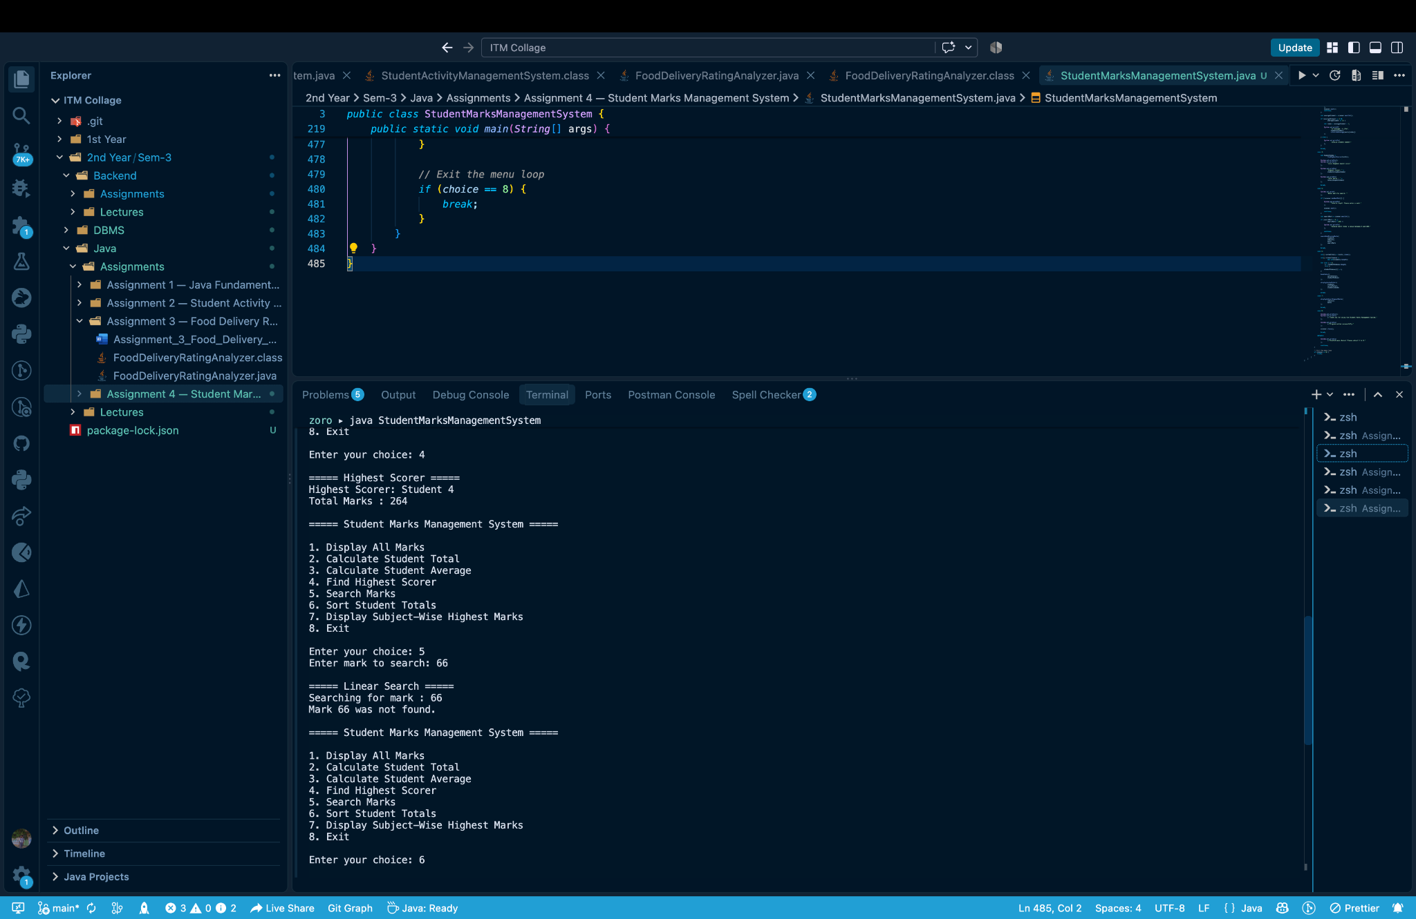
Execution Screenshot 4
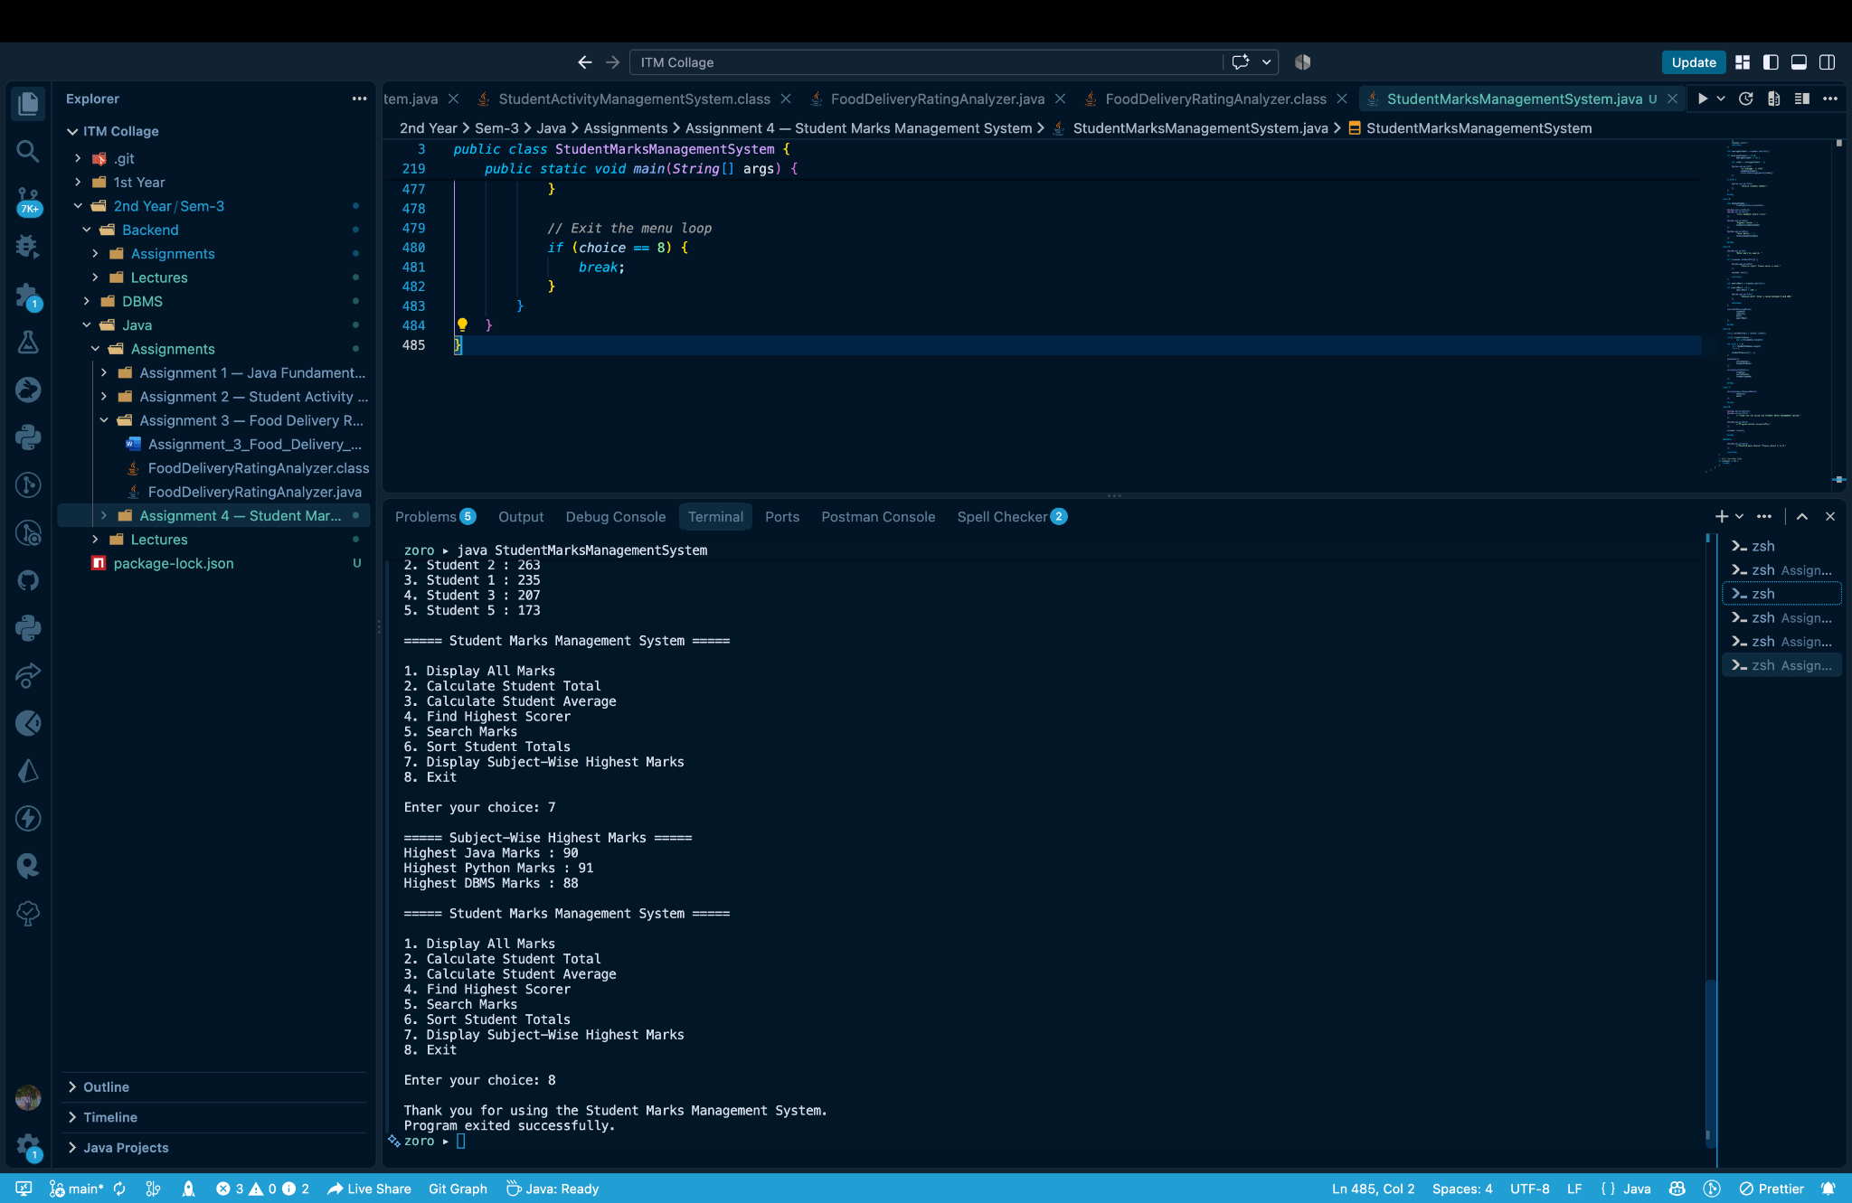

13. Result
The Student Marks Management System was successfully compiled and executed. The program correctly uses a 2-D marks array and 1-D totals array, separates operations into methods, accepts menu input through Scanner, performs Linear Search and Bubble Sort, identifies Student 4 as the highest scorer, and calculates subject-wise highest marks.

14. Conclusion
This assignment strengthened practical understanding of Java arrays, methods, parameter passing, searching, sorting, loops, switch-case control flow, and menu-driven application design. The successful test run confirms that the implementation meets the specified functional requirements.
— End of Assignment 4 Report —

